**Experiment 03**

**Aim:** Create a directory Vehicle. In Vehicle create three directories with names Fourwheelers, Threewheelers, Twowheelers.

• In Fourwheelers create directories Bus, Car, Truck.

• In Threewheelers create directories Auto.

• In Twowheelers create directories Cycle and Scooty.

In the Car directory, create files: Carbrand.txt, Busbrand.txt, Truckbrand.txt, Autocolor.txt, Cyclebrand.txt. Write 2 lines in each file. Move each file to their respective directories. Also, delete the Cycle directory finally.

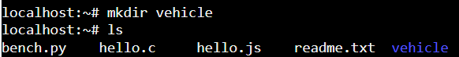**Step 1: Create a directory named Vehicle.  
mkdir Vehicle  
ls**

**Step 2: In vehicle directory create subdirectories - Fourwheelers, Threewheelers, Twowheelers.   
cd vehicle  
mkdir Fourwheelers Threewheelers Twowheelers  
ls**

**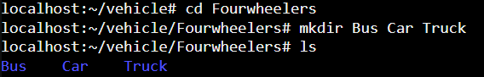  
  
Step 3: Inside the Fourwheelers directory, create the following subdirectories – Bus, Car, Truck.  
cd Fourwheelers  
mkdir Bus Car Truck  
ls**

**Step 4: Inside the Threewheelers directory, create a subdirectory named Auto  
cd Threewheelers  
mkdir Auto  
ls**

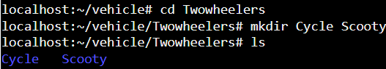**Step 5: Inside the Twowheelers directory, create the following subdirectories – Cycle, Scooty.  
cd Twowheelers  
mkdir Cycle Scooty  
ls**

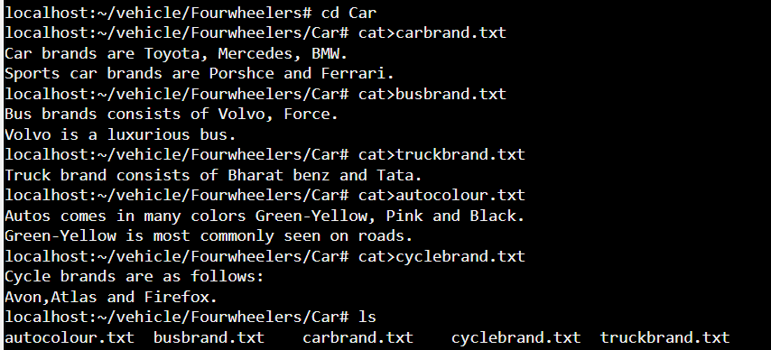**Step 6: In the Car directory, create the following files - Carbrand.txt, Busbrand.txt, Truckbrand.txt, Autocolor.txt, Cyclebrand.txt.  
cd Fourwheelers  
cd car  
cat > carbrand.txt  
cat > busbrand.txt  
cat > truckbrand.txt  
cat > autoclour.txt  
cat > cyclebrand.txt  
ls**

**Step 7: Now move the files to their respective directories.**



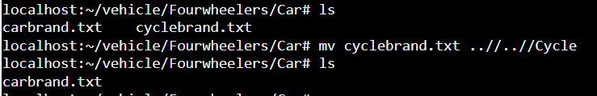

**Step 8: Delete the Cycle Directory**

